Budget – 1st Payroll of New School Year

Part 3



Presented by ESC, Region 14

2020

_____60. Create folder for your auditor. Run a Roster of Personnel (HRS 1000) before June Payroll and save in the Auditor folder.

____61. Process June Payroll.

_____62. Extract Service Records on all employees after June payroll is complete. (Separate document.)

_____63. Update Year of Service on all applicable employees. This step can be done in the Current or Next Year Pay Frequency however we recommend completing in NY Payroll since 12 month employees were made inactive after paying off in June.

Note: Step 63 should only be done ONCE for each pay type. Year of Experience cannot be “un” incremented so if a group of employees is incremented more than once, corrections must be made manually in each employee’s Employment Info screen.

Human Resources > Utilities > Mass Update > Employee
.
- Pay Type: 1-Contract Employee. In the Increment area, select Total (Prof) Experience, District (Prof) Experience. Enter the date 90 days before the end of the school year. Execute. Preview will display affected employees. Review information and process if accurate.

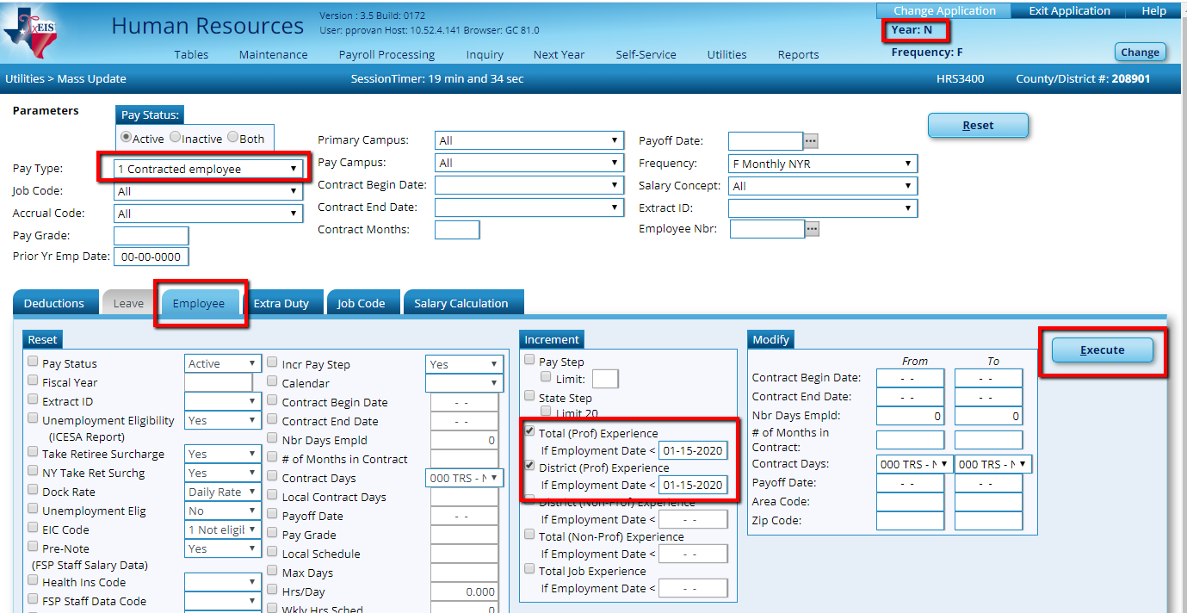
Dates should be
90 work days before
the end
of the school year.
Your dates
M may be different.

Dates should be
90 work days before
the end
of the school year.
Your dates
M may be different.

- Pay Type 2 - Non-contracted employees increment District (Non Prof) Experience and Total (Non-Prof) Experience. Enter date 90 days prior to the endo of school.

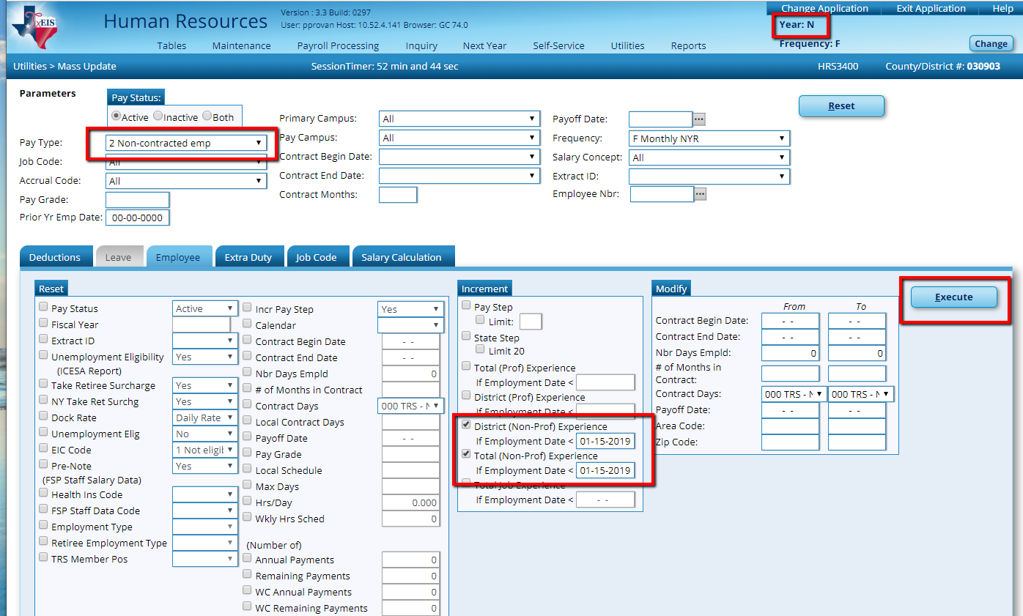
Dates should be
90 work days before
the end
of the school year.
Your dates
M may be different.

- Repeat for Pay Type 3 using Prof or Non-Prof as appropriate.

Human Resources – Current Year

_____ 64. Process TRS reporting for June Payroll.

Before the July Payroll

Human Resources – Next Year Pay Frequency

_____65. Copy Next Year Tables to Current Year. In Next Year Pay Frequency,

Next Year > Copy NYR Tables to CYR.

Select ONLY the tables used by 12 month employees.

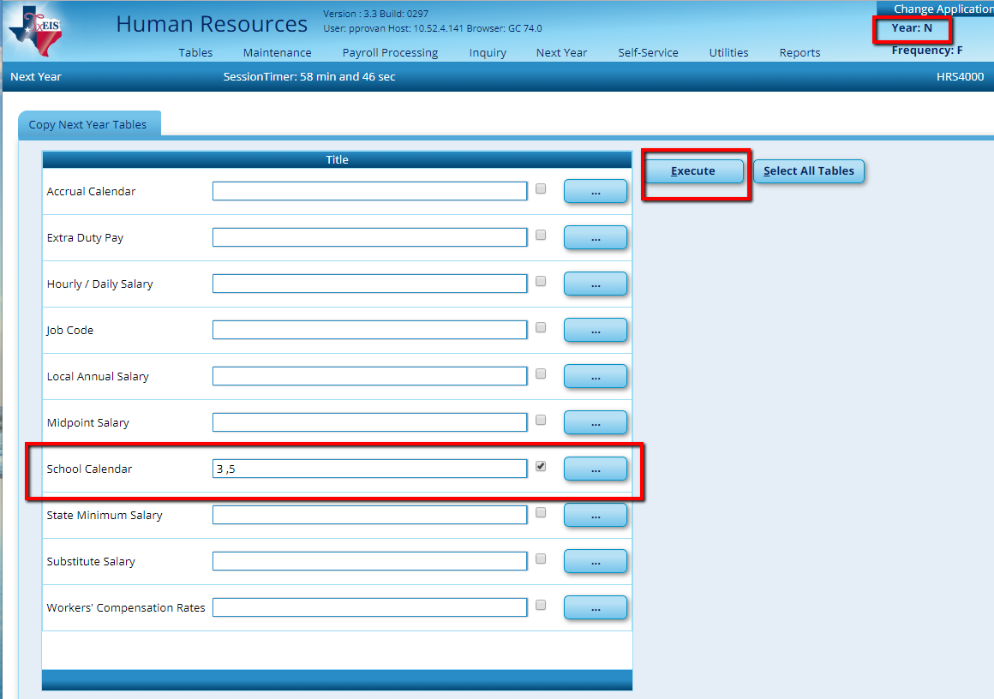

The most common tables associated with 12 month employees are School Calendars. Calendars for 12 month employees may be selected individually by clicking on the ellipsis button to the right. In the popup box, select the appropriate calendar(s) and click OK. Do not Copy the TRS Calendar or any calendar used by 10 or 11 month employees.

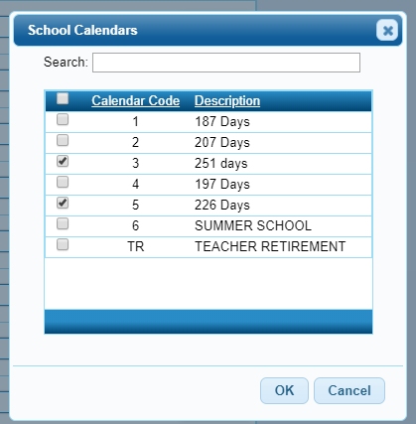

When returned to the Copy Next Year Tables screen, the box for School Calendars will be selected (if a calendar was selected,) but only the code(s) for the 12 month School Calendar(s) will be displayed in the Title. Execute and click Process at the preview of each table.

Note: If any other tables used by 12 mo. employees were changed, such as salary or extra duty tables, you must also copy those to current.

_____66. Move 12 month employees from Next Year Payroll to Current Year to prepare for the July payroll from Next Year > Copy NYR Staff to CYR. (Use Extract IDs if you have assigned those, or Contract Begin and End Dates if you are not using Extract IDs.) Execute and Process.

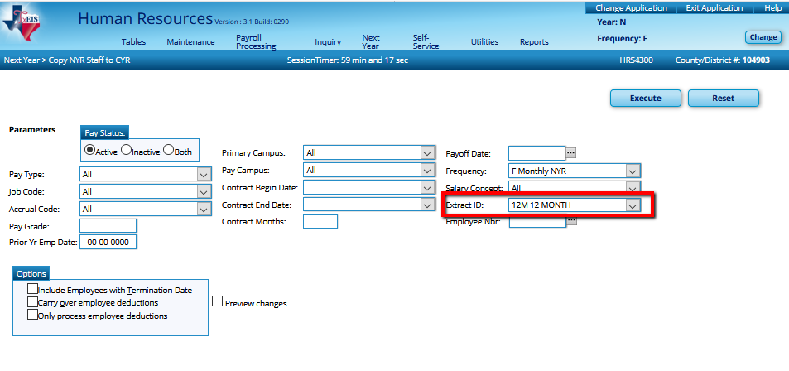
Do you need to include emp. with termination date?
Have you changed deduction info? If so, check to carry deduction over.

Note: Once employees are moved to Current Pay Frequency, they become Inactive in NY Payroll. If you plan to send payroll amounts to Budget again, you must re-activate these employees so their salary will be included in the Budget amounts.

To Re-Activate the 12 month employee in Next Year Payroll, you will go to Utilities > Mass Update in Parameters > Employee tab
- Choose Inactive Pay Status and
- Select by employee or Contract Begin Dates.
- On the Emplyee tab, select Pay Status 1 Active.
- Process at the preview.

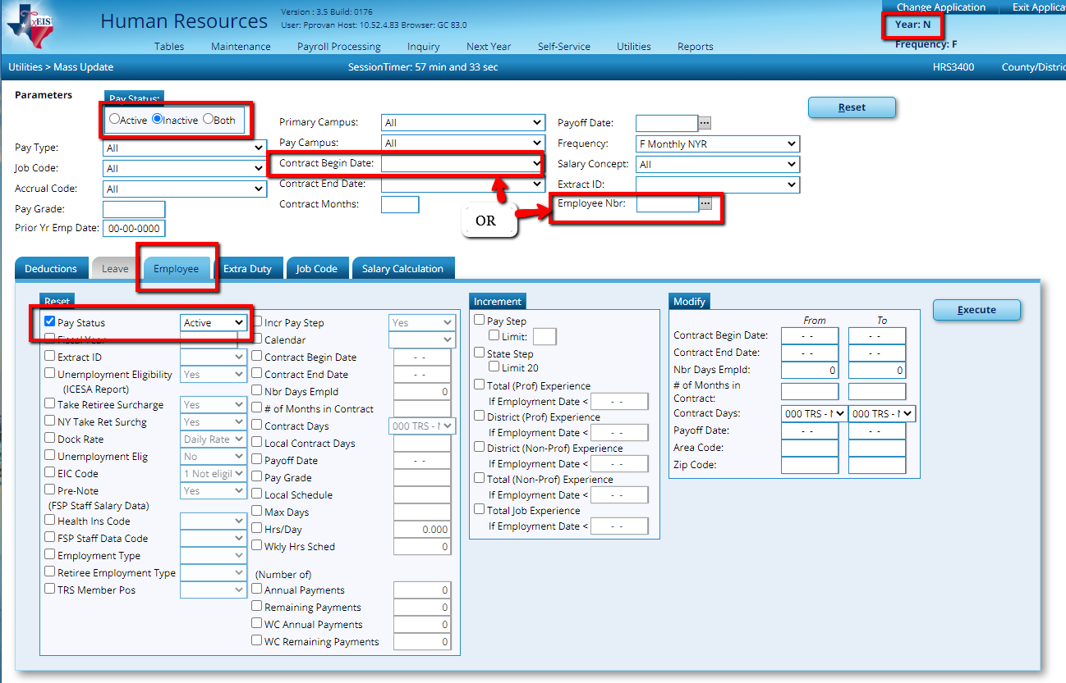

However, you must also be careful to inactivate them again so you don’t accidentally send them over to Current Payroll again later, over-writing the data there.

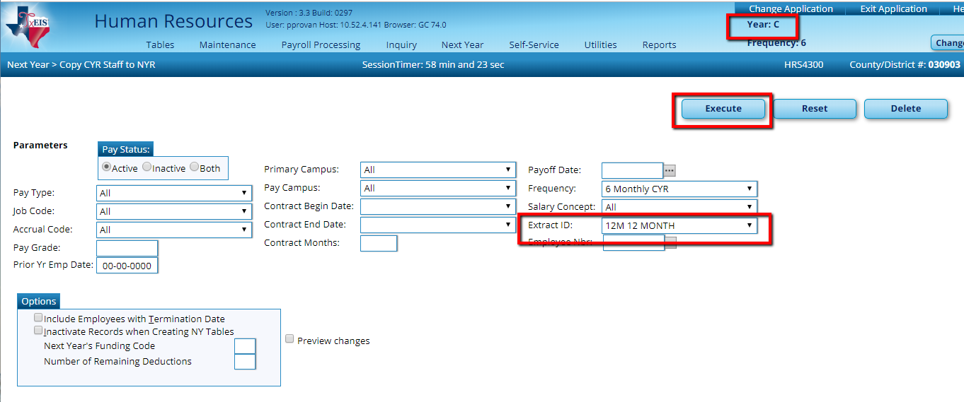

Human Resources – Current Pay Frequency
_____67. Reset the funding year on the Distributions Tab in Current Year for the 12 month employees. We mass updated distributions to a funding year 1 in Next Year Payroll, however the funding year should remain an 0 until September 1, so you will likely have to change funding years in the distributions of these employees. From Utilities > Mass Update > Employee tab in Current Year Payroll, select Extract ID for 12 month employees, check the box in front of Fiscal Year, and enter an 0 in the box to the right. You may have to do this step several times to pull all the 12-month employees listed in the Extract ID. Execute and Process at the Preview.

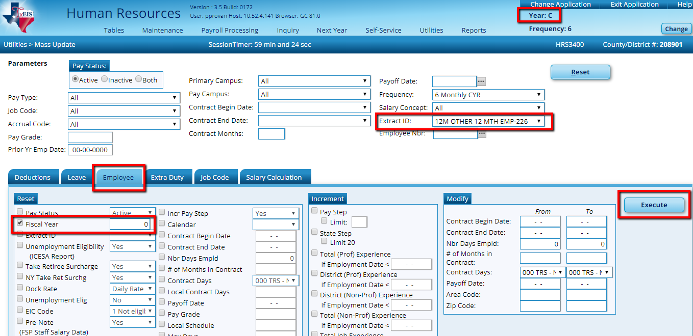

_____68. Process July Payroll and complete TRS reporting.

Human Resources – Next Year Pay Frequency

_____69. After July payroll, copy the calendar for 11 month employees (if applicable.) From Next Year > Copy NYR Tables to CYR, select ONLY tables used by 11 month employees. The 11-month calendar may be selected individually by clicking on the ellipsis button to the right of School Calendar. In the popup box, select the 11-month calendar only (if applicable,) check the correct Calendar Code box and click OK.

When you are returned to the Copy Next Year Tables screen, the box for School Calendars will be selected (if a calendar was selected,) but only the code for the 11 month School Calendar will be displayed in the Title. Execute and click Process the preview.

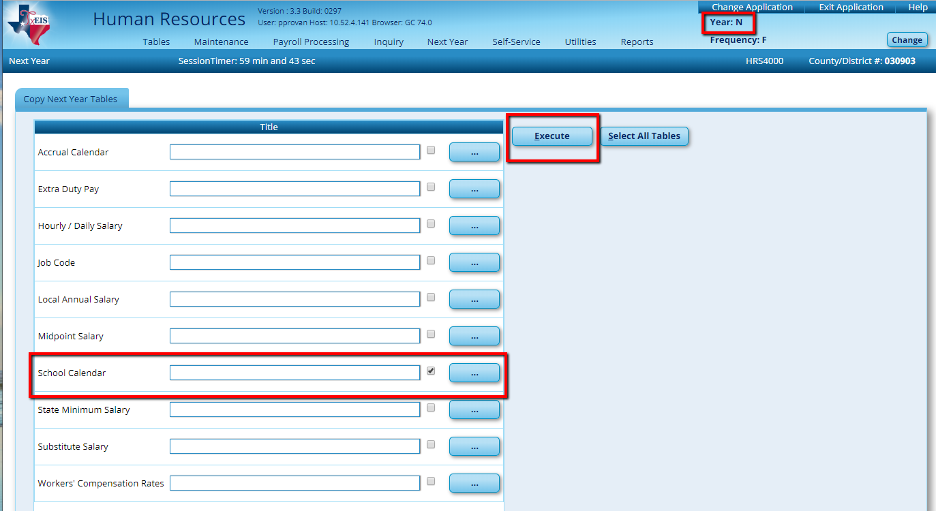

Note: If any other tables used by 11 month employees were changed, such as salary or extra duty tables, you must also copy those to Current.

_____70. Move 11 month employees from Next Year Payroll to Current Year to prepare for the August payroll from Next Year > Copy NYR Staff to CYR. (Use Extract IDs if you have assigned those, or Contract Begin and End Dates if you are not using Extract IDs.) This step will Inactivate the 11-month employee in Next Year and Activate them in Current. Execute and Process.

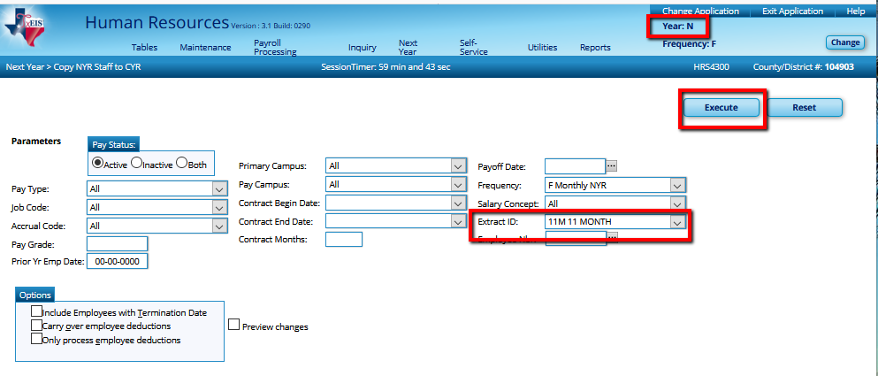

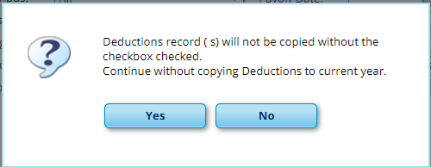

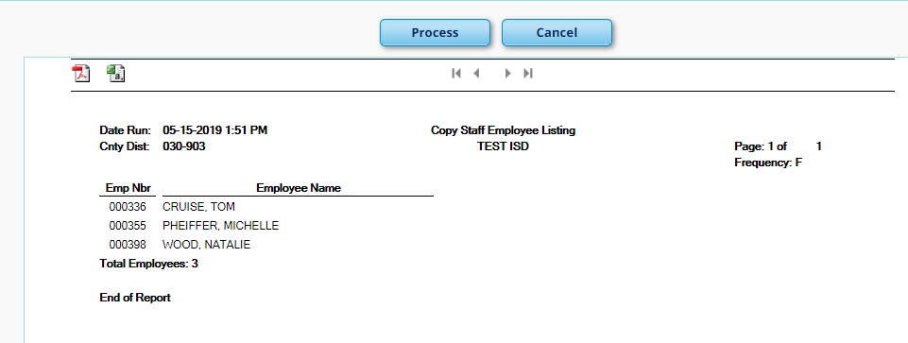

Reminder: Once employees are moved to Current Pay Frequency, they become Inactive in NY Payroll. If you plan to send payroll amounts to Budget again, you must re-activate these employees so their salary will be included in the Budget amounts. However, you must also be careful to inactivate them again so you don’t accidentally send them over to Current Payroll again later, over-writing the data there. See Notes on Step 66.

To Re-Activate the 11month employee in Next Year Payroll, you will go to Utilities > Mass Update in Parameters > Employee tab
- Choose Inactive Pay Status and
- Select by employee or Contract Begin Dates.
- On the Emplyee tab, select Pay Status 1 Active.
- Process at the preview.

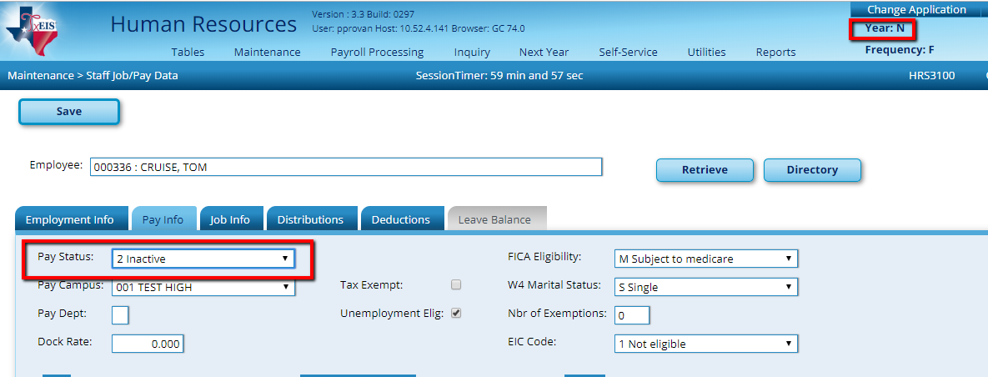

Human Resources – Current Pay Frequency

_____ 71. Reset the funding year on the Distributions Tab in Current Year for the 11 month employees. We mass updated distributions to a funding year 1 in Next Year Payroll, however the funding year should remain a 0 until September 1, so you will likely have to change funding years in the distributions of these employees. From Utilities > Mass Update > Employee tab in Current Year Payroll, select Extract ID for 11 month employees, check the box in front of Fiscal Year, and enter an 0 in the box to the right. Execute and Process at the Preview.

